**Step followed for Railway Booking Ticket Project (SSMS & SSRS)**

* SQL Server Management Studio

**Step 1 - Create a new database**

CREATE DATABASE RailwayBookingDB

use RailwayBookingDB

**Step 2 - Create 1st tables: PassengerMaster**

CREATE TABLE PassengerMaster (

PNRno INT PRIMARY KEY,

Name NVARCHAR(50),

Age INT,

Sex NVARCHAR(10),

Address NVARCHAR(100)

);

**Step 3 - Create 2nd tables: AccountMaster**

CREATE TABLE AccountMaster (

PNRno INT,

Amount DECIMAL(10,2),

TransactionID NVARCHAR(20),

TransactionDate DATE,

FOREIGN KEY (PNRno) REFERENCES PassengerMaster(PNRno)

);

**Step 4- Create 3rd tables: Journey_Details**

CREATE TABLE Journey_Details (

PNRno INT,

DeparturePlace NVARCHAR(50),

ArrivalPlace NVARCHAR(50),

DepartureDate DATETIME,

ArrivalDate DATETIME,

BerthNo NVARCHAR(10),

TrainNo INT,

Class NVARCHAR(50),

FOREIGN KEY (PNRno) REFERENCES PassengerMaster(PNRno)

);

* Check Table Structure

Select * From PassengerMaster

Select * From AccountMaster

Select * From Journey_Details

**STEP 5: Insert Sample Data in all Table**

-- Insert data in Passenger table -----

INSERT INTO PassengerMaster VALUES

(547298, 'Krish', 28, 'Male', 'Kolkata'),

(547300, 'klk', 26, 'Male', 'Indore'),

(547301, 'Riya', 25, 'Female', 'Mumbai'),

(547302, 'Aman', 29, 'Male', 'Delhi'),

(547303, 'Sneha', 26, 'Female', 'Indore'),

(547304, 'Raj', 25, 'Male', 'Patna'),

(547305, 'Pooja', 37, 'Female', 'Patna'),

(547306, 'Vikram', 26, 'Male', 'Chennai'),

(547307, 'Meera', 42, 'Female', 'Lucknow'),

(547308, 'Arjun', 20, 'Male', 'Kolkata'),

(547309, 'Nisha', 39, 'Female', 'Bangalore');

-- Insert data in Account-----------

INSERT INTO AccountMaster VALUES

(547298, 1200.00, 'TC178267', '2017-06-08'),

(547300, 599.12, 'TC1000', '2025-07-10'),

(547301, 1402.37, 'TC1001', '2025-07-10'),

(547302, 658.24, 'TC1002', '2025-07-10'),

(547303, 687.4, 'TC1003', '2025-07-10'),

(547304, 1081.46, 'TC1004', '2025-07-10'),

(547305, 628.97, 'TC1005', '2025-07-10'),

(547306, 1043.54, 'TC1006', '2025-07-10'),

(547307, 1145.55, 'TC1007', '2025-07-10'),

(547308, 700.6, 'TC1008', '2025-07-10'),

(547309, 919.78, 'TC1009', '2025-07-10');

-- Insert data in Journey table --------

INSERT INTO Journey_Details VALUES

(547298, 'Kolkata', 'Patna', '2025-07-20 20:33:10', '2025-07-21 07:30:15', 'B3,56', 79216,'2AC'),

(547300, 'Patna', 'Lucknow', '2025-07-20 20:00:00', '2025-07-21 07:00:00', 'S5,12', 79000, 'Sleeper'),

(547301, 'Bangalore', 'Indore', '2025-07-20 21:00:00', '2025-07-21 07:00:00', 'B2,45', 79001, '2AC'),

(547302, 'Bangalore', 'Patna', '2025-07-20 22:00:00', '2025-07-21 05:00:00', 'B3,56', 79002, '3AC'),

(547303, 'Chennai', 'Mumbai', '2025-07-20 23:00:00', '2025-07-21 08:00:00', 'S1,23', 79003, '1AC'),

(547304, 'Chennai', 'Kolkata', '2025-07-21 00:00:00', '2025-07-21 09:00:00', 'S2,34', 79004, 'Sleeper'),

(547305, 'Chennai', 'Bangalore', '2025-07-21 01:00:00', '2025-07-21 08:00:00', 'S3,67', 79005, '2AC'),

(547306, 'Kolkata', 'Indore', '2025-07-21 02:00:00', '2025-07-21 12:00:00', 'A1,78', 79006, '3AC'),

(547307, 'Jaipur', 'Bangalore', '2025-07-21 03:00:00', '2025-07-21 14:00:00', 'A2,90', 79007, '1AC'),

(547308, 'Indore', 'Hyderabad', '2025-07-21 04:00:00', '2025-07-21 14:00:00', 'C1,22', 79008, 'Sleeper'),

(547309, 'Bangalore', 'Chennai', '2025-07-21 05:00:00', '2025-07-21 15:00:00', 'C2,11', 79009, '2AC');

**STEP 6: Create View for Reporting**

------- Create View for Reporting-----------------------------------------

CREATE VIEW vw_RailwayTicketReport AS

SELECT

p.PNRno,

p.Name,

p.Age,

p.Sex,

p.Address,

a.Amount,

a.TransactionID,

a.TransactionDate,

j.DeparturePlace,

j.ArrivalPlace,

j.DepartureDate,

j.ArrivalDate,

j.BerthNo,

j.TrainNo,

j.Class

FROM PassengerMaster p

JOIN AccountMaster a ON p.PNRno = a.PNRno

JOIN Journey_Details j ON p.PNRno = j.PNRno;

select * from vw_RailwayTicketReport

* STEP 7: Open SSRS & Design the Report in SSRS

• **Add Data Source - DS_**RailwayBooking

* Embedded Connection
* Type: Microsoft SQL Server
* Connection String: Connect to your RailwayBookingDB

• **Add Dataset - DT_**RailwayBooking

* Use embedded dataset
* Query:

SELECT * FROM vw_RailwayTicketReport WHERE PNRno = @PNRno

• **Add Parameter**

* Name: PNRno
* Type: Integer (because PNR will be number)

**STEP 8: Design Report Layout with Table and image insertion and run**

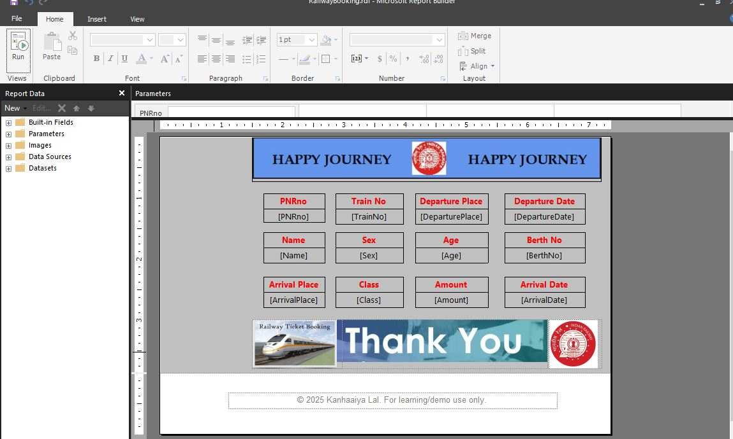

## STEP 9: Preview and Export

* Click **Run**
* Enter PNR no 547298 to test
* You should now see a **ticket-like output**

